Hart’s Ladder of Participation
Hart's Ladder is a model developed by Roger Hart, an environmental psychologist and children's rights advocate, to describe the levels of children and young people's participation in decision-making.
Hart created this framework in response to the United Nations Convention on the Rights of the Child, particularly Article 12, which establishes children's right to express their views on matters affecting them. Recognising that many well-intentioned adult efforts to involve young people often fell short of genuine participation, Hart developed the ladder to help distinguish between authentic engagement and mere tokenism.
The model includes eight rungs, with the bottom representing tokenism or manipulation and the top representing meaningful, youth-led participation. The ladder helps educators and organisations reflect on the authenticity and impact of student voice initiatives, providing a practical tool for evaluating whether young people are truly being heard and empowered in decision-making processes.

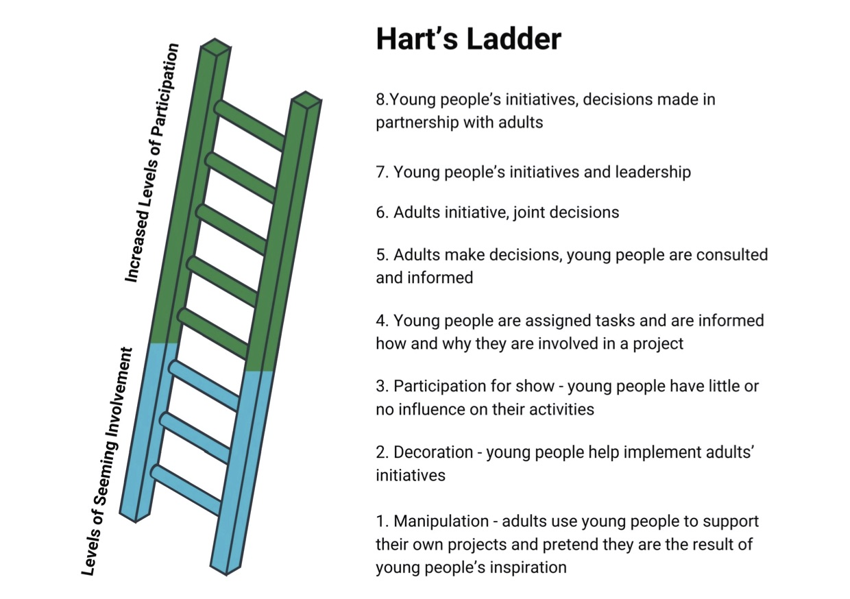

The 8 Rungs in more detail
1. Manipulation
Young people are used to support adult agendas under the appearance of participation. They have no understanding or input and no real voice. For example, students might be asked to read pre-written speeches at a school board meeting about budget cuts, with no opportunity to understand the issues or express their own views. The school uses their presence to suggest student support for decisions already made by adults.
2. Decoration
Children take part in activities but do not understand the purpose or process. Their presence is used to make a project look inclusive. A school might invite students to sit on a committee about uniform policy changes but provide no background information or explanation of the decision-making process. Students attend meetings but cannot contribute meaningfully because they don't understand what's being discussed or why their input matters.
3. Tokenism
Young people may appear to be involved, but they have little real power or influence. Their voices are used without meaningful engagement. Students might be asked to complete surveys about school facilities, but their responses are ignored when final decisions are made. The school can claim they consulted students while continuing with predetermined plans that don't reflect student priorities.
4. Assigned but informed
Young people are given roles and responsibilities and are fully informed about the purpose. Their involvement is real, but still directed by adults. Teachers might assign students to represent their year level on a school council committee, providing them with clear briefings about issues and expectations. Students understand their role and contribute genuinely, though the agenda and decision-making process remain adult-controlled.
5. Consulted and informed
Young people are consulted on adult-led projects. Their views are taken seriously, and they understand how their input will influence decisions. When planning a new playground, the school might hold focus groups with students, clearly explaining the budget constraints and design options. Student feedback directly influences the final design choices, and students receive updates on how their input shaped the outcome.

6. Adult-initiated, shared decisions with children
Adults start the project but decision-making is shared. Children's voices genuinely shape outcomes, and there is a strong sense of partnership. A teacher might identify the need for a peer mentoring program but work collaboratively with students to design its structure, select participants, and create training materials. Both adults and students have equal say in key decisions about how the program operates.
7. Child-initiated and directed
Young people lead and manage their own initiatives. They make the decisions and take responsibility, while adults support when needed. Students might identify mental health as a priority issue and independently organise awareness campaigns and fundraising activities. Teachers provide resources and guidance when requested but don't direct the project's goals or methods.
8. Child-initiated, shared decisions with adults
Young people initiate projects or ideas and involve adults as equal partners. This is the highest form of participation, where intergenerational collaboration is built on trust and mutual respect. Students might propose creating a school garden and invite teachers, parents, and community members to join as equal partners in planning, funding, and maintaining the project. Decision-making is truly collaborative, with both young people and adults contributing their unique perspectives and expertise.

